**Lesson Eighteen: The Rich Ruler**

**Journey to Jerusalem. Concerning Divorce (Matthew 19:1-12; Mark 10:1-12)**

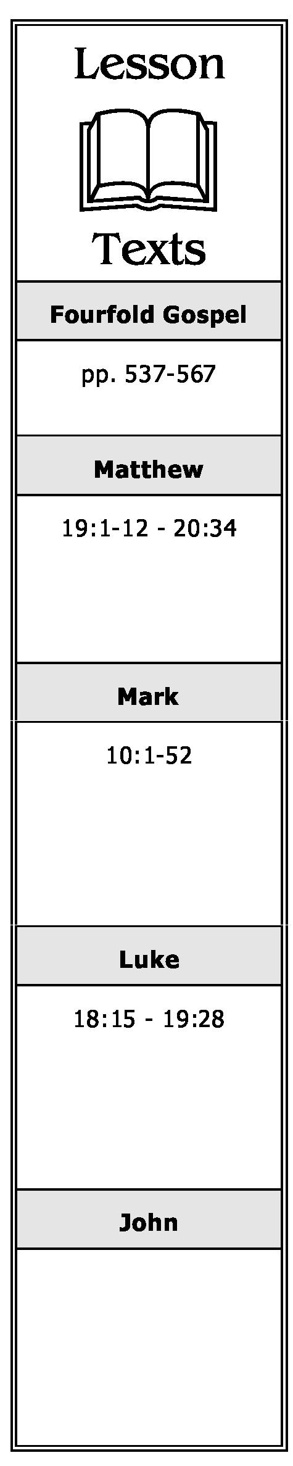

1. Why did the Pharisees ask Jesus if it were lawful for a man to put away his wife for every cause? What was His response?
2. After receiving an answer from Jesus, what did the Pharisees then ask Him in regard to divorce? What was His reply? Explain the meaning of Jesus’ reply.
3. If one puts away his wife for any cause other than fornication (sexual immorality) and marries another, of what sin is he guilty? Who else is guilty of that same sin? Explain.

**Blessing Children. Concerning Childlikeness   
(Matthew 19:13-15; Mark 10:13-16; Luke 18:15-17)**

1. Why were little children brought to Jesus on this occasion? What was the reaction of His disciples? What was Jesus’ response to His disciples?
2. What lesson does Jesus teach using the little children as His example?

**The Rich Ruler. Peril in Riches. The Reward of Sacrifice. The Parable of the Laborers in the Vineyard (Matthew 19:16 - 20:16; Mark 10:32-45; Luke 18:18-30)**

1. Briefly summarize what took place when the rich young ruler came to Jesus.
2. For whom, according to Jesus, is it difficult to go to heaven? Why? What illustration did He use to show how difficult it is?
3. What did Jesus say would be the reward of those who had left all to follow Him?
4. Briefly summarize the parable of the laborers in the vineyard. What is its main lesson?

**A Chronological Study of the Life of Jesus Gene Taylor 48**

**Foretelling His Passion. Rebuking Ambition (Matthew 20:17-28; Mark 10:32-45;Luke 18:31-34)**

1. What did Jesus say would happen to Him in Jerusalem?
2. What request was made of Jesus by James and John and their mother? What was His response to them?
3. What makes one great in the kingdom of heaven?

**Bartimaeus and His Companion Healed (Matthew 20:29-34; Mark 10:46-52; Luke 18: 35-43)**

1. What miracle did Jesus perform on Bartimaeus and another man? What were the results of this miracle?

**Zacchaeus. The Parable of the Pounds. Journey to Jerusalem (Luke 19:1-28)**

1. Who was Zacchaeus? How did Jesus meet him?
2. What request did Jesus make of Zacchaeus? How did he respond?
3. Why, according to His statement in Verse 10, did Jesus come to earth? Explain what He meant.
4. Briefly summarize the parable of the pounds. What lesson does it teach? What application, if any, can be made of its teaching today?

**A Chronological Study of the Life of Jesus Gene Taylor 49**